This form sets out the criteria which meets the ParentAssess Quality Assured Standard.
It can be used by instructing solicitors, managers and proof-readers.
Some social workers may use the ParentAssess tools within other assessments and should then cite the reference (Lowe 2016). If, however, they are stating the assessment is a ‘ParentAssess’ certain key components MUST be completed, otherwise it is not a ParentAssess assessment. These are marked on this form in bold and are available on our website.
The ParentAssess Assessor training sets out the ways in which social workers should work with parents during the assessment process, according to their specific needs, and how to identify these needs. This approach should enable parents to be engaged throughout the process and to understand the outcome. We hope all social workers apply the recommended approaches and complete reports which are evidence based and contain the necessary analysis.

Once training has been completed, we recognise social workers may use the ParentAssess Framework in different ways. Assessments may be of varying quality. The QA Standard sets out what should be done in a ParentAssess assessment, especially if used within Care Proceedings or to inform decision making.
If an assessor adds the ParentAssess QA mark to their assessment, they are stating the report meets this standard.
If a solicitor or Local Authority would like a report which meets this standard, we would suggest they ask social workers if they use the QA mark. 8 – 12 weeks will be required to complete this work.
If a social worker uses the mark but does not meet this standard, they either need to declare any reasons why this was not achieved (and should have explained this within their full report), or those commissioning the assessment may challenge the assessor and they should inform ParentAssess Ltd.
Although this form is detailed, it is expected those commissioning reports will quickly become familiar with what should be contained in the assessment.
Please email info@parentassess.com for more information or to report any concerns.

 | Yes | No | Notes
Was the parent given an assessment plan or did the assessor explain to the parents what the assessment would involve?

Has the assessor completed 6 sessions with the parents (excluding observations) and ensured the parents have had sufficient opportunity to process information? (In exceptional circumstances, e.g. where the assessor already knew the family well, this number of visits may be slightly reduced although this would need to be spelt out and justified in the assessment, and time still given to measure change, once any adaptations allowing for their disability had been put in place, as set out later.)

Has the assessor been clear about how many visits they did with the parent(s)?

Are the paragraphs in the full report numbered simply from 1 upwards to the final paragraph? There should be no sub paragraph headings like paragraph 2.4.5.a etc. as this is confusing for many parents.

Throughout the assessment is the parent referred to by their first name? (They should be Kirsty rather than Ms Kirsty Smith or Ms Smith as parents engage better when this convention is used.)

Is the full report written using clear straightforward language? Do they avoid jargon and acronyms?

Was the Strengths and Concerns Record completed with the parent and with a professional who knows the family (which may be the assessing social worker if completed by a LA SW)?

Was a summary table then made and shared with the parents by the start of session 2? This ensures the parent knows what they need to do and what the worries are.

Have at least 2 (preferably 3) observations been completed with the parent and all children involved?

Has clear feedback been given to the parent? This is to ensure the parent is given the opportunity to develop.

Has the Knowledge and Confidence Booklet been completed? (You will know this if the information is in the Outcome Table and if the assessor references this in the report. Areas not applicable may be left blank in the table).

Has the assessor set out how they have tailored their approach to the risks/concerns of this situation and to the specific needs of this parent (either from observation and/or a cognitive assessment, and (for example) using visual aids, taking breaks, communicating information differently etc.)?

Has the parent's ability to learn and use adaptive strategies’ been assessed?

Are there examples where the assessor has checked the parent’s ability to take on new information and apply it?

Has the assessor spoken to any child over 4/5 about their experience of being parented?

Has the assessor stated which other formal tools and assessments (e.g. hair-strand tests) informed the assessment?

Has the assessor gathered additional information from other professionals or family/friends?

Has the assessor clearly considered what support can be put in place/if this can plug any gaps in parenting, and have they assessed how realistic and sustainable this support would be?

Is there a completed Outcome Table (see the example below)?

NB - There should be some colours in every column and the table should include all the headings in the table below. Depending on how the software used, P2 may be blank or not appear if there was no second parent, similarly there may be blank or additional “Child” columns if there were or were not two, three or more children considered as part of the assessment. Some columns (especially “Observations”, “Child”, “Other Tools” and “Other Info”) will usually have some empty squares within them.
Has the Short Parent Report been written in clear straightforward language and given to the parent? Does this reflect the findings in the Main Report and the Outcome Table?

Have the parents been given this in a format they can understand? For example, large print, translated if needed.

Does the appendix contain the completed
- Outcome Table?
- Assessor’s Summary?
- Short Parent Report?

Are the tables printed in colour so the parent can understand and see the reds, ambers and greens? NB - This needs to be the same in the bundle etc. so parties can understand the outcome.

Are the report findings backed up by evidence?

Example extract of the Outcome Table
Questionnaires, scales, drug/ alcohol tests etc.
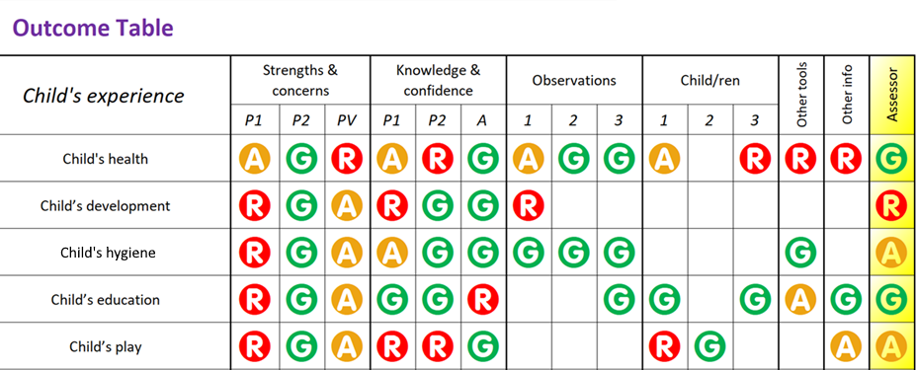
Direct work with the child
Lateral checks, support network info etc.

Example assessor’s summary
The assessor’s overall final grade for each area
area
Green  This is what the parent does well | Amber  These are areas where there are some concerns but with help the parent is likely to develop their parenting skills within 6 months | Red  These are things where I have concerns and where the parent has not shown enough insight or ability to change.
- Child’s home  - Child’s diet  - Domestic abuse  - Drug use  - Alcohol use  - Managing your housing situation  - Current relationship  - Other issues  - Gambling  - Offending  - Employment | - Child’s hygiene  - Child’s education  - Parent’s health  - Daily tasks  - Managing money  - Parent history  - Trauma  - Parent’s mental health  - Past relationships  - Managing your online life  - Support from professionals  - Accessing services  - Parent’s self-care  - Managing relationships with friends and family  - Keeping yourself safe from others | - Child’s health  - Child’s development  - Child’s play  - Child’s routine  - Child’s feelings  - Child’s behaviour  - Keeping your child safe from others  - Managing brothers and sisters  - Decision making  - Learning and adapting  - Dealing with stress  - Support from family and friends  - Thinking ahead  - Multi-tasking

Example Short Parent Report
The final heading could be adapted to “what I am going to tell everyone at the next meeting” if used in Pre-Proceedings. This report should be no longer than 3 (preferably 2) pages long, in a larger font and increased line spacing.

Short Parent Report

This is the summary of your Parenting Assessment

I have written a long report which will be given to your solicitor. They will go through this with you. I have put this summary together which might be easier to read and understand.

Things I think which are good and you do well are

You are very loving towards Nancy and talk to her in a gentle loving way.

Your care of Nancy in family time has been really good.

You have thought about the mistakes you made, and you have worked hard to sort things out.

You went to the parenting programme and listened to advice and changed what you do.

You have people around you who now know where you need help. You are no longer worried about asking for help.

Things I was worried about
I do wonder whether you might let Clive back in your life - it’s important you don’t.

It is possible you will get together with another man like Clive but I hope you will remember all you have learnt and that this doesn’t happen.

You do still struggle with routines. But I think with the support of your aunt and using Alexa you will be able to do what you need to.

You still need help with your money, but your aunt will help with this.

Although you have made some really good changes but there is more to do. You need to keep trying hard.

What I have decided to tell the court

I know you love Nancy very much and with support and help from your aunt I think Nancy should carry on living with you. But is important you keep making the really good changes you have been making.

